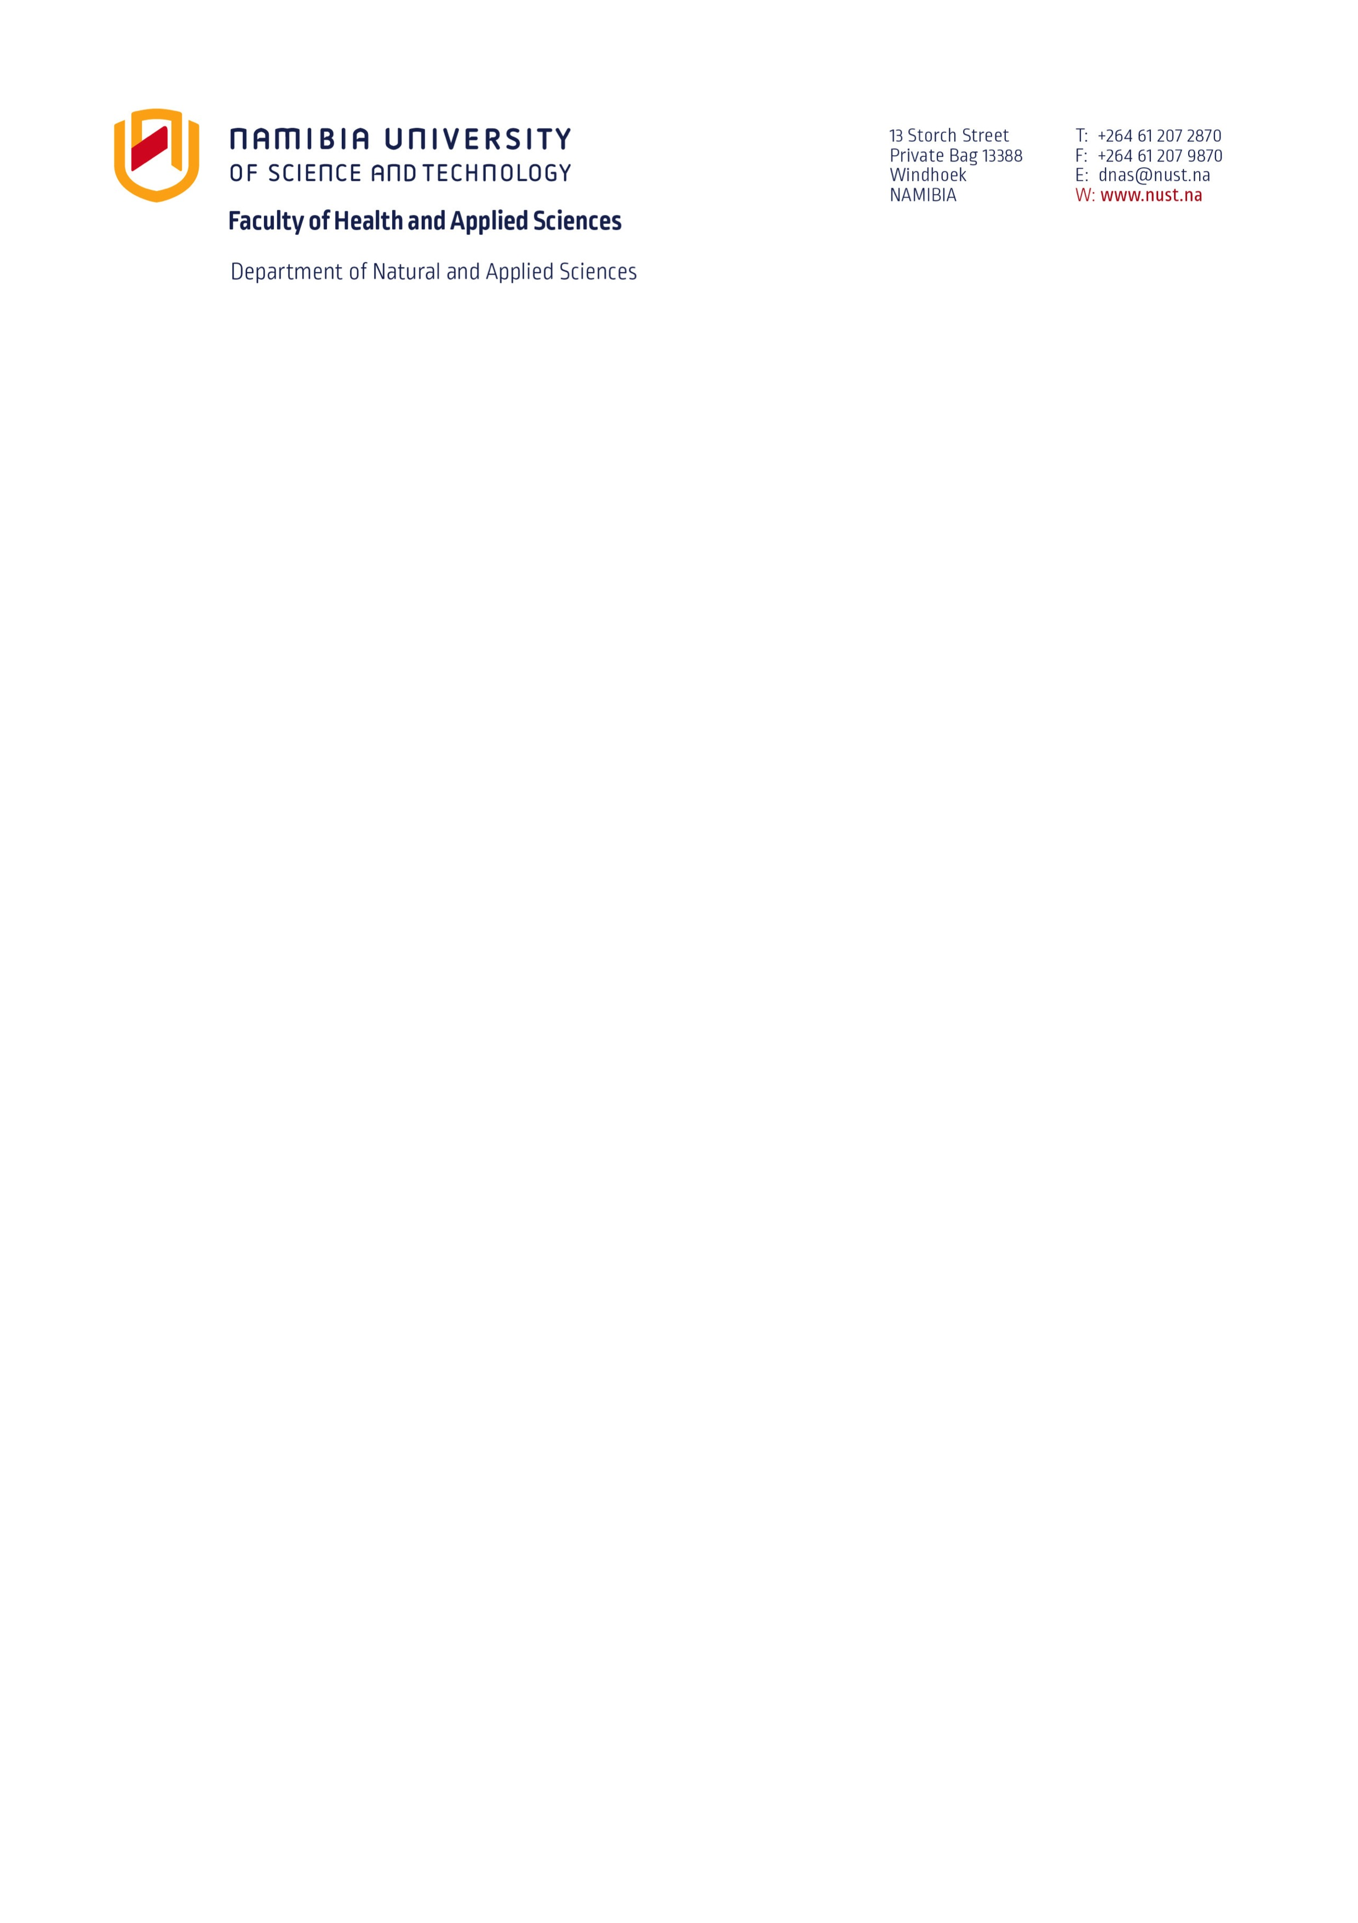

Programme: All programmes

Course Outline
Name of Course: Basic Science
Course Code: BSC410S
Compiled by: Dr Vaino Indongo

STATEMENT ABOUT ACADEMIC HONESTY AND INTEGRITY

All staff and students at the Namibia University of Science and Technology (NUST), upon signing their employment contracts and registration forms, commit themselves to abide by the policies and rules of the institution. The core activity of NUST is learning and in this respect academic honesty and integrity is very important to ensure that learning is valid, reliable and credible.

NUST therefore does not condone any form of academic dishonesty, including plagiarism and cheating on tests and assessments, amongst other such practices. NUST requires students to always do their own assignments and to produce their own academic work, unless given a group assignment.

Academic Dishonesty includes, but is not limited to:
- Using the ideas, words, works or inventions of someone else as if it is your own work.
- Using the direct words of someone else without quotation marks, even if it is referenced.
- Copying from writings (books, articles, webpages, other students’ assignments, etc.), published or unpublished, without referencing.
- Syndication of a piece of work, all or part of an assignment, by a group of students, unless the assignment was a legitimate group assignment.
- The borrowing and use of another person’s assignment, with or without their knowledge or permission.
- Infringing copyright, including documents copied or cut and pasted from the internet.
- Asking someone else to prepare an assignment for you or to write or sit an assessment for you, whether this is against payment or not.
- Re-submitting work done already for another course or programme as new work, so-called self-plagiarism.
- Bringing notes into an examination or test venue, regardless of whether the notes were used to copy or not.
- Receiving any outside assistance in any form or shape during an examination or test.

All forms of academic dishonesty are viewed as misconduct under NUST Student Rules and Regulations. Students who make themselves guilty of academic dishonesty will be brought before a Disciplinary Committee and may be suspended from studying for a certain time or may be expelled. All students who are found guilty of academic dishonesty shall have an appropriate endorsement on their academic record, which will never be erased.

COURSE INFORMATION

COURSE CODE AND TITLE:
BCS410S: Basic Science

DEPARTMENT:

Biology, Chemistry and Physics

PROGRAMME:
Institutional Core Course

CONTACT HOURS:
4 hours per week (Fulltime Mode)
3 hours per week (Parttime Mode)
2 times per month, 4 hours each session (Distance Mode)

NQF LEVEL AND CREDIT:
Level 4 Credits 8

COURSE DESCRIPTION:

This semester course forms part of the Institutional Core requirements and is designed to provide students with a basic understanding of the fundamentals/principles of Biology, Chemistry and Physics. The course will enable students to appreciate the relevance of natural sciences and apply basic concepts/principles in their everyday lives.

PRE-REQUISITES:
None

COURSE EQUIVALENCIES:
[Delete this text and enter any course equivalencies. This is particularly relevant in programmes that are being phased out. Consult the transition rules of such programmes for detail. Delete this section if none exist]

COURSE DELIVERY METHODS:
[ (e.g. Classroom, Blended, Online, Clinical, Co-operative Ed., Distance Ed., Other]

The following communication tools will be used in this course:
[Delete this text and enter communication tools students will be required to uses in this course (e.g. Email, Discussion Board, Scheduled Chats, Unscheduled chats, Teleconference calls, Online content, other)]

Course Format:
[Delete this text and provide a brief narrative of how the course will be conducted. Indicate the ratio of lecture to lab hours and planned activities (where appropriate) that will assist the student in mastering the course learning outcomes (e.g. study groups, field trips, practicum, etc.)]

EFFECTIVE DATE:
[Delete this text and enter the start date of this course]

LECTURER INFORMATION
Windhoek Main Campus, Health and Applied Sciences Building
- Lecturer’s name: Dr Vaino Indongo, Course Coordinator, Physics Lecturer
Email: vindongo@nust.na, Tel: 061 207 2346, Office Number: 3.235 (3rd Floor, Right Wing).
- Lecturer’s name: Mr Pedro Tjakwanda, Physics Lecturer (Fulltime)
Email: ptjakwanda@nust.na, Tel: 061 207 2687, Office Number: 3.242 (3rd Floor, Next to Elevator).
- Lecturer’s name: Mrs Leonoritha Naomas, Biology Lecturer (Fulltime)
Office location:
Email: ___________ Tel: 061 207 xxxx, Office Number: None.
- Lecturer’s name: Ms Justine Awene, Chemistry Lecturer (Fulltime)
Office location: Faculty of Health and Applied Sciences,
Email: jawene@nust.na, Tel: 061 207 xxxx, Office Number: xxxx
- Lecturer’s name: Mr Tuwilika Tobias, Chemistry Lecturer (Distance)
Office location: Faculty of Health and Applied Sciences, 3rd Floor (Right Wing)
Email: ttobias@nust.na, Tel: 061 207 2803, Office Number: 3.226
- Lecturer’s name: Mr Ambicious Lifasi, Physics Lecturer (Distance and Parttime)
Office location: Health and Applied Sciences Building, 3rd Floor
Email: alifasi@nust.na, Tel: 061 207 xxxx, Office Number: 3.289, 3rd Floor (Left Wing).
- Lecturer’s name: Mrs Marta Elvin, Chemistry Lecturer (Distance)
Email: melvin@nust.na, Tel: 061 207 2830, Office Number: 3.280 (Third Floor, Right Wing).

Office hours: See Timetables
Consultation hours: All lecturers are available for consultation with students. Consultation times can be found on the doors of lecturers’ offices.

Any other Teaching Assistant that may be involved during the semester will be introduced to the students and all information will be provided thereof.

STUDENT READINESS

Technology & Equipment Readiness:

Certain components of this course will be on e-learning: the Syllabus, PowerPoint lectures, and chapter quizzes. Please check e-learning often as important announcements will be posted on the home page.

Student Commitments And Contact Times:
Students must attend all theory classes as per timetable

Course Resources: N/A

Prescribed Reading:
NUST Study Guide

Recommended Reading:
Any Introduction/Fundamental to Biology, Introduction to Chemistry and Introduction to Physics Textbook

Any recent General Biology, General Chemistry and General Physics Textbook

Michael Roberts, Michael Reiss, Grace Monger. (2000). Advanced Biology. Nelson.

George.I.Sackheim, Dennis D. Lehman. (2009). Chemistry for the Health Science, Eighth Edition, Pearson Education International.

G.F.Liptrot. Modern Inorganic Chemistry. (4th ed.). Colline Educational.

Ntombenhle Dlamini, Hella Rust, Marithabile Khanyanu, Jame Webb and Jenny-Lee. Biology for Southern Africa. Macmillian

STUDENT LEARNING

Learning Outcomes:
Upon completing the course students will, through assessment activities, show evidence of their ability to:
Biology
- Describe life and life processes of living organisms;
- Explain the major parts of the plant structures and their function;
- Describe the life cycle of animals;
- Describe the basic importance of micro-organism used in food production, industry and medicine;
- Explain the importance of food that humans consume every day;

Chemistry
- Describe and discuss the general properties of matter;
- Explain the phase changes that matter undergoes;
- Demonstrate understanding of the basic terminology of the elements and their compounds;
- Explain some of the key elements in the periodic table (mainly metal and non-metal);
- Discuss the importance of acid, base, buffer and the uses of pH scale;
- Discuss the importance of water to the human body;
- Perform basic mathematical manipulations such as unit analysis with proper attention to units and significant figures;
- Express numbers in scientific notation.

Physics
- Interpret graphs and use data to draw graphs;
- Discuss the major sources of energy and alternative sources of energy;
- Discuss the basic concepts and uses of electricity for everyday life;
- Give and discuss examples of practical applications of radioactive isotopes;
- Recognise, discuss and calculate the effects of forces;

COURSE SCHEDULE:

 | Topic | Assignments
Unit 1 ((2 weeks) | Living Things
Unit 2 (1 week) | Ecology
Unit 3 (1 week) | Chemistry of Food
Unit 4 (1 week) | Microbiology and Biotechnology
Unit 5 (1 week) | The Properties and Structure of Matter
Unit 6 (1 week) | The Periodic Table
Unit 7 (1 week) | Acids, Bases and Salts
Unit 8 (1 week) | Measurement in Science
Unit 9 (1 week) | Graphs
Unit 10 (1 week) | Forces
Unit 11 (1 week) | Sources of Energy
Unit 12 (1/2 week) | Electricity
Unit 13 (1/2 week) | Radioactivity

IMPORTANT DATES:
NOTE: The following dates are subject to change based on the needs of the students at the lecturer’s prerogative. Students will be notified ahead of time of any changes.

Date | Important Information
 | Full-Time and Part-Time Students
Assignment 1 | Thursday, 13th March 2025  FM and PM: Complete Assignment online on the given date  DI: Submitting typed PDF document through TurnItIn link
Test 1 | Saturday, 15th March 2025  09h00 – 11h00 FM + PM + DM: Eng. Basement (A & B) & Regional Centres
Assignment 2 | Wednesday, 16th April 2025  FM and PM: Complete Assignment online on the given date  DI: Submitting typed PDF document through TurnItIn link
Test 2 | Thursday, 17th April 2025  17H30 – 19H30 FM + PM + DM: Eng. Basement (A & B) & Regional Centres
Test 3 (Supplementary Test) | Tuesday, 06th May 2025 at 17h30 – 19h30  FM + PM + DI: Eng. Basement (A & B) & Regional Centres

ASSESSMENT AND EVALUATION:

Assessment | Weight
Assignment 1 | 15%
Assignment 2 | 15%
Test 1 | 25%
Test 2 | 25%
Quiz Averages | 20%
Total: | 100%

Minimum pass requirement for this course: [Final Mark of 50% computed from both Exam and Assessment Marks]

COURSE POLICIES
General Academic Policies:
It is the student's responsibility to be familiar with and adhere to NUST’s Policies. These Policies can be found in NUST Prospectus or online at www.nust.na/prospectus.

Supplementary Policies:

Note that:
- Supplementary tests will only be written by students with varied reasons, and no extra assignment unless prior arrangement (i.e. 10 days in advance) is made, so make sure that you write all the assessments in the scheduled times.
- All Seventh Day Adventist students should provide their details so that arrangements will be made in advance.
- The last day for exemption and cancellation of courses with 100% credit is 25 February 2025.
- Quizzes contribute to CASS mark; each quiz is written after a completion a chapter.
- Students must ensure that all their assessments marks for the semester are recorded correctly on the Student Kiosk on or before Monday, 19 May 2025.

DATE REVISED: N/A

ACKNOWLEDGEMENTS:
N/A

ADDITIONAL INFORMATION/FREQUENTLY ASKED QUESTIONS:
N/A

FAILURE TO PAY FEES:

A student who fails to pay his/her fees may not be allowed to write the examination and if allowed, the results will be withheld until all outstanding fees are paid in full.

IMPORTANT STUDENT SERVICES AT NUST

There are a variety of services which you can use at the NUST. These services are to your advantage – Use them!!! They include the following:

- Student Counseling and Career Development – Department: Students Services
- Writing Centre and student academic problems –Teaching and Learning Unit (CTL)
- Campus Health and Wellness Centre (CHWC) - Student Services’/ NUST Clinic

AUTHORISATION:
This course is authorised for use by:

10/02/2025
___________________________________ __________________________
Head of Department Date

ACKNOWLEDGEMENT BY STUDENT

(To be completed by all students on the course, detached from the course outline and kept on record in the department)

I, (insert name), (Student number), hereby acknowledge that I have received this course outline for Basic Science (BSC410S) and that I have familiarised myself with its content, in particular the statement about academic honesty and integrity. I agree to abide by the Policies and arrangements spelt out in this course outline.

______________________ _______________________
Signature of Student Date

